Information Required for Company Profile & Marketing Content

1. Company Overview
- Brief introduction about your company.

Company Overview
Sometimes, all we need is the right guidance at the right time.
Whether you're a student choosing a career, a professional exploring new opportunities, or a parent trying to make the best decision for your child, the journey can often feel overwhelming. That's why My Skill Counsellor was founded in 2023—to be a trusted guide, helping individuals navigate important academic and career decisions with clarity and confidence.
At My Skill Counsellor, we believe that every individual has unique strengths, aspirations, and potential. Founded by a mother, career counsellor, and mentor, our approach goes beyond admissions and applications. We take the time to understand every student's aspirations, support every parent's concerns, and provide honest, personalised guidance that helps individuals make informed decisions and build a future they truly believe in.

- Your mission, vision, and core values.
Vision
To inspire individuals to discover their potential, embrace opportunities, and create a future they truly believe in.

Mission
At My Skill Counsellor, we believe guidance doesn't begin in Class 12—it begins much earlier. Our mission is to walk alongside individuals and families at every stage of their journey, helping them discover their strengths, navigate opportunities, and make informed decisions with confidence, honesty, and purpose.

Core Values
We Listen Before We Guide
Every journey is unique. We take the time to understand before we advise.
Trust & Transparency
Honest advice, always in the individual's best interest.
Beyond Academics
We believe success is shaped not only by marks, but also by skills, aspirations, values, and personal growth.
Guidance for Life
Our role is not just to help people reach a destination, but to help them make confident decisions for their future.

- How your organization acts as a bridge between students and universities.

Guidance That Puts You First
At My Skill Counsellor, every recommendation begins with understanding the individual, not just the university. We take the time to understand aspirations, strengths, academic background, and career goals before recommending institutions that are the right fit.
Every journey begins with a conversation. We encourage individuals to share their dreams, research, and preferred universities, and then offer honest, unbiased guidance based on their profile. If a university isn't the right fit, we believe in being transparent rather than making false promises. Our commitment is to help every individual make informed decisions with confidence and find the path that's truly right for them.
- What makes your company unique in the study abroad industry.

What Makes My Skill Counsellor Unique?
At My Skill Counsellor, we believe that every individual deserves personalised guidance, not a one-size-fits-all approach. We consciously focus on quality over quantity, giving each student and family the time, attention, and support they truly deserve.
Our relationship doesn't begin with university applications, nor does it end with an admission letter. We walk alongside our students through every stage of their study abroad journey—from profile building, university selection, applications, visas, and pre-departure preparations to helping them settle into a new country. Whether it's answering questions, easing concerns, or simply being there when guidance is needed, we strive to ensure that every student and parent feels supported, informed, and confident throughout the journey.

2. Services Offered
Please provide detailed information about all services offered, including:

How We Support Your Study Abroad Journey
1. Before the Offer Letter — Building the Right Foundation
Career & Profile Assessment • Profile Building • Course & University Selection • Study Abroad Planning • SOP & LOR Guidance • Application Support • Interview Preparation • IELTS Preparation
2. After the Offer Letter — Preparing for the Move
Final University Selection • Offer Acceptance Guidance • Visa Support • Financial Documentation Guidance • Accommodation Support • Pre-Departure Guidance • Packing & Travel Planning • Banking, Insurance & Currency Guidance
3. After Departure — Settling into Your New Life
Arrival & Settling-In Support • Local Transport & Safety Guidance • SIM, Banking & Healthcare Guidance • Campus & Academic Orientation • Daily Living Support • Personalised Check-ins During the Initial Transition

Also share:
- List of partner universities and institutions.- no need
- Details of tie-ups, collaborations, and strategic partnerships.- no need

3. Blogs & Knowledge Resources
Please share:
- Links to published blogs and articles.
- https://www.linkedin.com/pulse/one-story-step-daily-lessons-from-my-path-day-0-ria-vkf2c
- https://www.linkedin.com/posts/riajain26_a-mothers-journey-of-learning-to-let-go-activity-7477334864858345472-c7NN?utm_source=social_share_send&utm_medium=member_desktop_web&rcm=ACoAAClBJu4BRZFv7BreULj10-xogiz1UcSS78E
- https://www.linkedin.com/pulse/career-story-counsellor-part-1-ria-lnoxc
- Educational resources created by your company.-none
- Student success stories and case studies. - no case studies
Success story- https://www.linkedin.com/posts/riajain26_studentsuccess-careercounselling-studyabroad-activity-7449459855624441856-BBZH?utm_source=social_share_send&utm_medium=member_desktop_web&rcm=ACoAAClBJu4BRZFv7BreULj10-xogiz1UcSS78E
THREE OFFERS → THREE DIFFERENT PROGRAMS → ONE INFORMED DECISION
The Student Goal
Find the right undergraduate business and marketing program in Dubai.
The Outcome
3 offers from international universities.
Our Role
University and program comparison, personalised counselling, and decision support based on the student’s profile, career goals, and long-term direction.
The Next Step
Choosing the university and program that best fits the student’s future.

- Industry insights and study abroad guides. none

4. Awards, Recognition & Media Coverage
Kindly provide:
- Awards and recognitions received by the company.
- 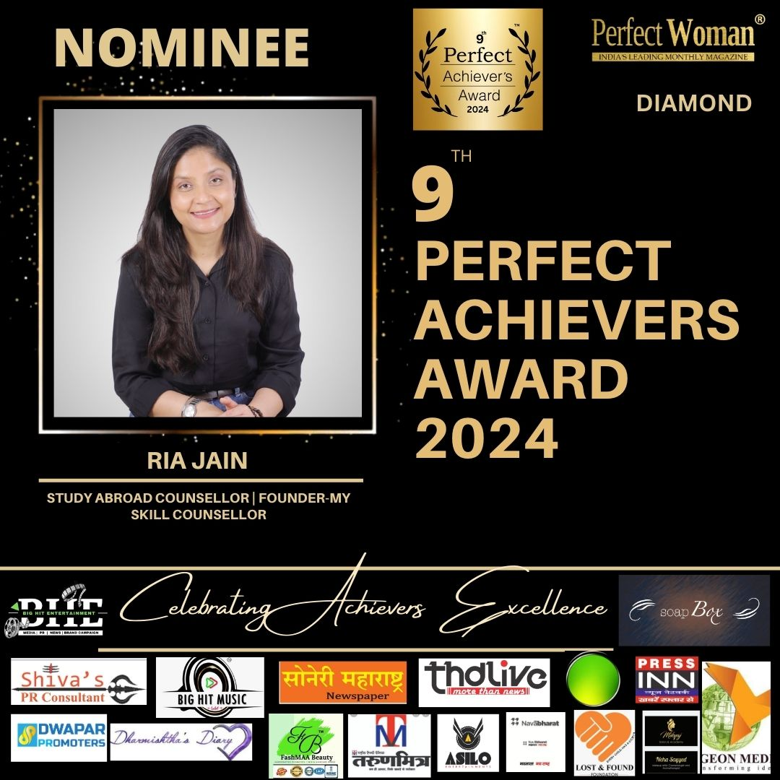
- Certificates of achievement.
MA English https://drive.google.com/file/d/1nCf-64QLptZQfCwG85Z34-1mBKPnfoyx/view?usp=sharing

- Photographs of award ceremonies.
- Newspaper articles, magazine features, press releases, and media coverage.
- High-resolution images for promotional use.

5. Student Placement & University Success Stories
Please provide:
- Names of universities where your students have secured admissions.
- Student success stories.
- Number of students placed annually.
- Notable achievements of students.

6. Global Reach
Please share:
- Countries where you provide study abroad services.
- Number of partner universities in each country.
- Popular destinations among your students.

7. Testimonials & Reviews
Kindly provide:
- Student testimonials.
- Parent testimonials.
- Video testimonials (if available).
- Google reviews and ratings.
- Any other customer feedback or success stories.

8. Short Company Introduction (Marketing Version)
Please provide a concise and impactful company introduction highlighting:
- Expertise in overseas education.
- Trusted student guidance.
- Global university network.
- High visa success rate.
- Personalized counseling.
- Student-focused approach.
- Industry experience and achievements.

9. Social Media Presence
Please share the links to your official social media profiles:
- Website
- Facebook
- Instagram
- LinkedIn
- YouTube
- Twitter/X
- WhatsApp Business
- Any other active platforms

10. Additional Marketing Assets (Optional)
- Company logo (high resolution).
- Brand guidelines.
- Team photographs.
- Office photographs.
- Promotional videos.
- Brochures and presentations.
- Any other marketing materials.
We look forward to receiving the above information to help us create impactful branding and promotional content for your organization.
Note-- Skip the information which you had provided in last sheet
Thank you.
p3 innovations pvt ltd

